MEDICINE CHECKER SYSTEM
Project Report

Submitted by: Mayurakshi Bharadwaj
Roll Number: 25boe10103
Date: 30 March 2026

1. Introduction
The Medicine Checker System is a simple, console-based application developed in Python to manage and retrieve essential information about various medicines. The core motivation behind this project is to create a quick, reliable, and easily maintainable digital database for drug information. Access to accurate drug details—such as dosage, uses, side effects, and precautions—is vital for both end-users and small clinical environments.
The system utilizes a simple, in-memory dictionary data structure to store medicine records. It provides the full suite of CRUD (Create, Read, Update, Delete) functionalities, offering a robust foundation for a localized medical information reference tool. The Python implementation focuses on clarity, functional separation, and efficiency in data retrieval.

2. Problem Statement
In small-scale medical environments, or for personal reference, accessing drug information often relies on physical records or external online resources, which can be slow and unreliable.
The primary problem is to develop a functional, user-friendly, and maintainable system that provides the following capabilities:
- Data Storage: Store crucial medicine attributes (dosage, uses, precautions, etc.).
- Instant Retrieval: Allow users to search for any medicine by name to view its complete profile instantly.
- Data Management: Facilitate efficient database management through simple Add, Update, and Remove operations.

3. Functional Requirements
The system must perform the following specific functions:
- Search Medicine: Must allow searching by medicine name (case-insensitive) and display its full details (Uses, Dosage, Side Effects, Precautions, and Availability).
- Add New Medicine: Must allow the creation of a new entry, requiring input for all necessary medicine attributes. Must validate against existing entries.
- Update Existing Medicine: Must allow modification of one or more attributes of an existing medicine entry, with the option to skip fields if no update is necessary.
- Remove Medicine: Must allow the deletion of an existing medicine entry.
- Show All Medicines: Must display a concise list of all medicine names currently available in the database.
- User Interface (UI): Must provide a clear, console-based menu for interaction and navigation.

4. Non-functional Requirements
These requirements define the quality attributes of the system:
- Usability: The console interface must be intuitive, requiring minimal user training for operation.
- Maintainability: The source code must be modular (using separate functions) and well-commented, ensuring easy future modification.
- Performance: Search and retrieval operations must be near-instantaneous, leveraging Python's efficient data structures.
- Robustness: The system must handle common user errors (e.g., searching for a non-existent item) gracefully without crashing.

5. System Architecture
The system employs a simplified three-layer logical architecture, typical for a console application:
- Presentation Layer: Implemented by the main() loop and all print() / input() calls. This layer handles user interaction, menu display, and result presentation.
- Business Logic Layer: Comprises the core functions (search_medicine, add_medicine, update_medicine, remove_medicine, show_all_medicines). This layer executes the necessary data manipulation and validation logic.
- Data Layer: The global medicines dictionary. It acts as the persistent (in-memory) storage for all application data.

6. Design Diagrams
6.1. Use Case Diagram
This diagram illustrates the main functions accessible to the user actor.
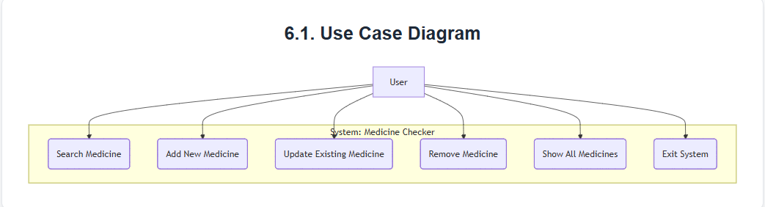

6.2. Workflow Diagram
The workflow diagram illustrates the sequence of operations within the main menu loop.

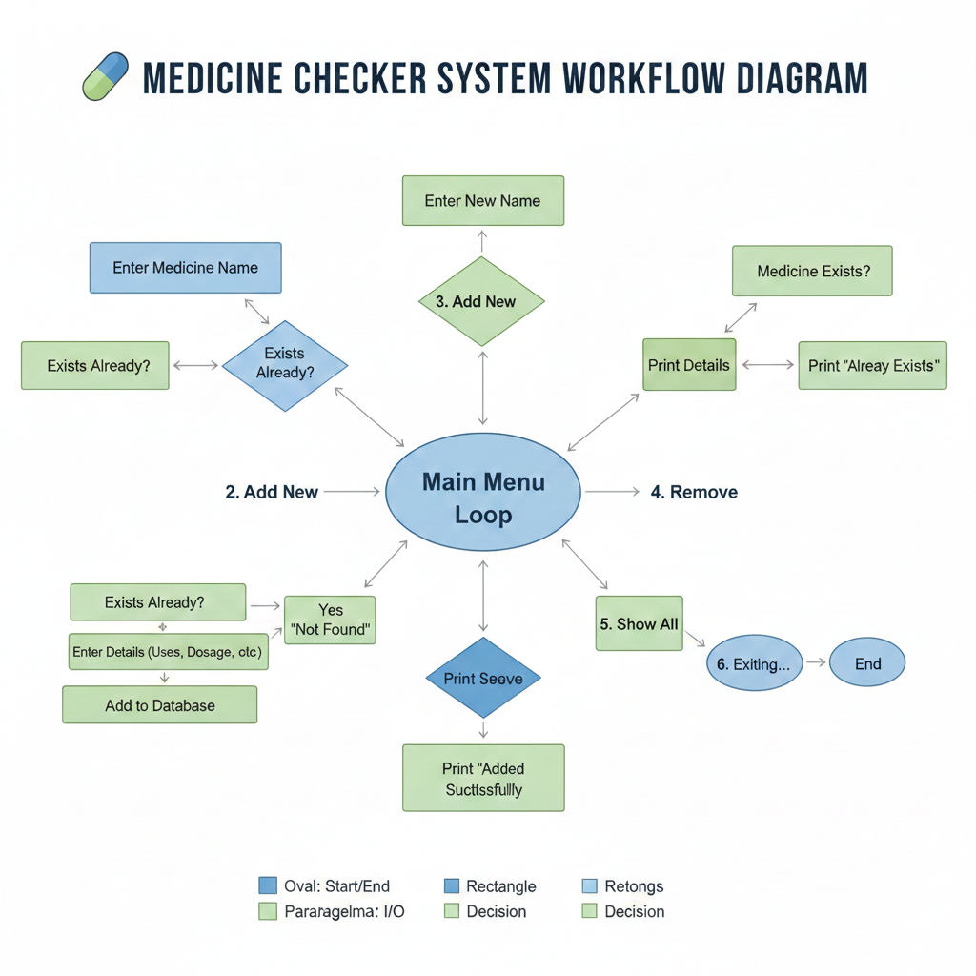

6.3. Sequence Diagram (Search Medicine)
This diagram visualizes the interaction flow when a user searches for a medicine
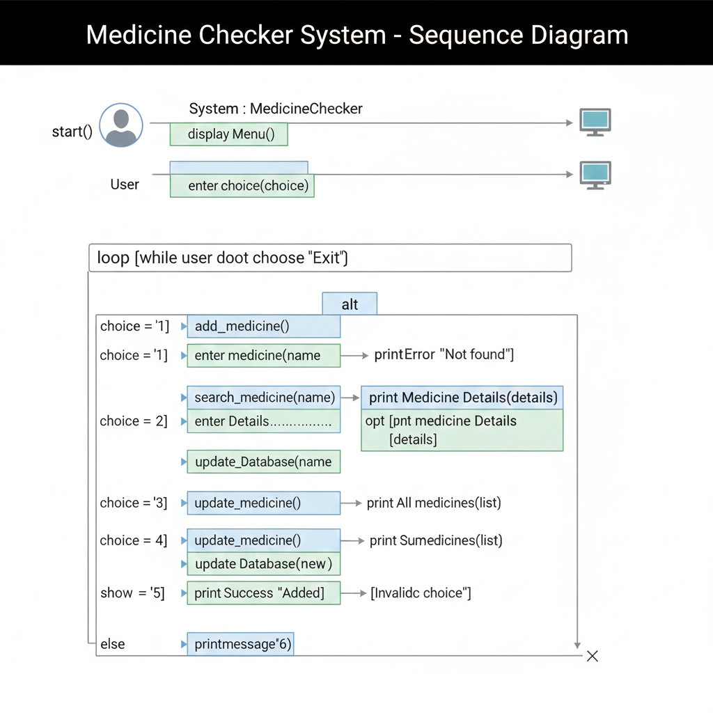

7. Design Decisions & Rationale
Decision | Rationale
Python Dictionary for Storage | Chosen for its O(1) average-case time complexity for search and data retrieval, making operations instantaneous for the key-value pairing (Name → Details).
Case-Insensitive Input | The .lower() function is used on all medicine names to ensure search reliability and improve user experience, regardless of capitalization.
In-Memory Database | Simplified the project by avoiding external database setup or complex file I/O, allowing focus on core application logic and data manipulation algorithms.
Modular Functions | Each system feature (Search, Add, Update, etc.) is encapsulated in its own function, adhering to the Single Responsibility Principle, aiding in maintenance and testing.
Partial Updates in update_medicine | Checks using if input_value: allow users to leave fields blank, ensuring that only fields with new, non-empty data are overwritten.

8. Implementation Details
The project is implemented entirely in Python 3. The core of the system revolves around manipulating the global medicines dictionary.
Data Structure Initialization
The data is initialized as a nested dictionary where the outer keys are medicine names and the inner values are dictionaries containing attributes:
medicines = {
"medomol": {
"dosage": "...",
"precautions": "...",
...
},
...
}
Core Logic Snippets
Search Logic: Uses dictionary lookup for efficient retrieval.
def search_medicine(name):
name = name.lower()
if name in medicines:
# Access and print details
else:
# Not found
Update Logic: Ensures only non-blank inputs are applied.
def update_medicine():
# ... check if medicine exists ...
uses = input("New uses: ")
if uses:
medicines[name]["uses"] = use
# ... repeat for other fields ..
.9. Screenshot
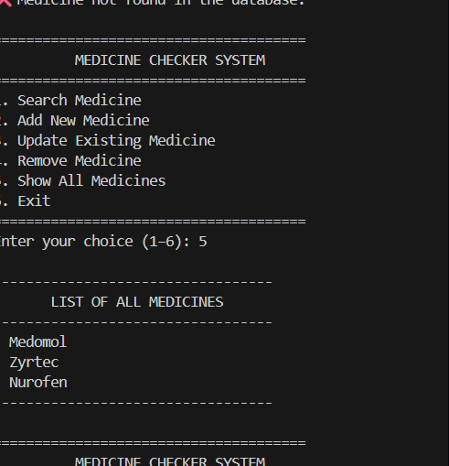

10. Testing Approach
A Unit Testing approach was utilized to verify the correctness and reliability of each individual function. Key areas tested included:
- Search Validation: Testing for both existing and non-existent medicine names, and testing case-insensitivity.
- Data Integrity (Add/Remove): Verifying that new data is correctly inserted and existing data is fully removed.
- Partial Update Functionality: Ensuring that fields left blank during an update do not clear the existing data.
Sample Test Cases
ID | Function | Input | Expected Result
TC-01 | search | "Medomol" (mixed case) | Details for "medomol" displayed successfully.
TC-02 | add | New med "aspirin" | Medicine added; count of total medicines increases by one.
TC-03 | update | Med: "zyrtec", New dosage only | Only the dosage for zyrtec is changed; other fields remain untouched.
TC-04 | remove | "nurofen" | "nurofen" is deleted from the database.
12. Challenges Faced
- Input Normalization: The initial challenge was ensuring consistent data access. This was solved by aggressively normalizing all input medicine names to lowercase before database lookup.
- Non-Destructive Updates: Designing the update_medicine function required careful conditional logic to prevent accidental deletion of existing data when a user only wanted to change one field. The solution hinged on checking the truthiness of the input strings (if uses:).
13. Learnings & Key Takeaways
- Data Structure Selection: Reinforced the practical benefits of using Python dictionaries for high-performance key-based lookups in data management systems.
- Modularity: Gained practical experience in creating modular code, emphasizing the benefits of separate functions for clear separation of concerns.
- User Interaction Design: Learned to structure a robust console application using a menu-driven infinite loop, a standard pattern for CLI tools.
- CRUD Implementation: Successfully implemented the fundamental building blocks (CRUD operations) required for almost any application that manages data.
14. Future Enhancements
The following features are planned for future versions to increase the utility and robustness of the system:
- Persistent Storage: Implementing file I/O (using JSON or CSV) to save the medicines dictionary to disk, allowing data to persist between program executions.
- Advanced Search Filtering: Allowing users to search by medicine attributes such as uses, side effects, or availability status.
- Input Validation: Adding stricter checks on user input (e.g., ensuring dosage fields contain numbers or specific units) to prevent data corruption.
- Graphical User Interface (GUI): Transitioning from the console application to a simple GUI (using Tkinter or PyQt) for better usability.
15. References
- Python 3 Documentation. https://docs.python.org/3/
- Python Dictionaries Tutorial (For data structure specific implementation).
- [Add references to any specific academic papers, libraries, or detailed tutorials used.]

